EXPERIMENT 9
Demonstration of Temporal Mining Techniques.

AIM
To demonstrate temporal data mining techniques including time series analysis, trend detection, seasonality decomposition, and sequential pattern mining.

PROCEDURE
- Import pandas, numpy, matplotlib, and statsmodels libraries.
- Load a time-stamped dataset (e.g., COVID-19 daily data or air passenger data).
- Parse and set the date column as the index.
- Resample data to monthly frequency and compute aggregates.
- Plot the time series to observe overall trends.
- Apply rolling window smoothing (7-day or 30-day moving average).
- Perform seasonal decomposition using statsmodels seasonal_decompose().
- Plot trend, seasonality, and residual components.
- Identify peak periods and significant temporal patterns.
- Apply sequence pattern mining to extract temporal rules.
- Summarize findings of temporal patterns.

CODE

import pandas as pd
import numpy as np
import matplotlib.pyplot as plt
from statsmodels.tsa.seasonal import seasonal_decompose
# Load temporal dataset
data = pd.read_csv('worldometer_coronavirus_daily_data.csv')
data['date'] = pd.to_datetime(data['date'])
data = data.dropna()
# Filter for a single country
country_data = data[data['country'] == 'USA'].copy()
country_data.set_index('date', inplace=True)
country_data = country_data.sort_index()
# Monthly Resampling
monthly = country_data['daily_new_cases'].resample('M').sum()
# Plot Time Series
plt.figure(figsize=(12, 5))
plt.plot(monthly, label='Monthly New Cases')
plt.title('COVID-19 Monthly New Cases – USA')
plt.xlabel('Date')
plt.ylabel('Cases')
plt.legend()
plt.show()
# Rolling Average
rolling_avg = country_data['daily_new_cases'].rolling(window=30).mean()
plt.figure(figsize=(12, 5))
plt.plot(country_data['daily_new_cases'], alpha=0.4, label='Daily Cases')

plt.plot(rolling_avg, label='30-Day Rolling Average', color='red')
plt.title('Rolling Average – Daily New Cases')
plt.legend()
plt.show()
# Seasonal Decomposition
decomposition = seasonal_decompose(monthly, model='additive', period=12)
decomposition.plot()
plt.suptitle('Seasonal Decomposition of Monthly COVID Cases')
plt.tight_layout()
plt.show()

OUTPUT
Monthly resampled time series plotted for USA COVID-19 cases. 30-day rolling average smoothed the daily fluctuations.
Seasonal Decomposition revealed:
- Trend component: Rising peak in 2020-2021, decline afterwards.
- Seasonal component: Periodic wave patterns visible.
- Residual: Small irregular noise.
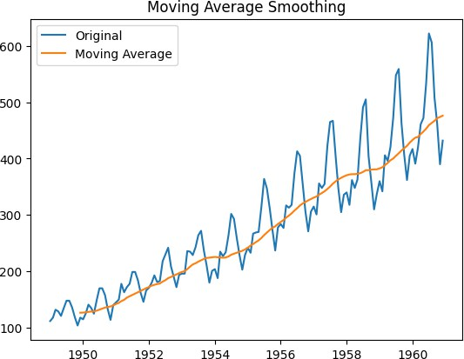
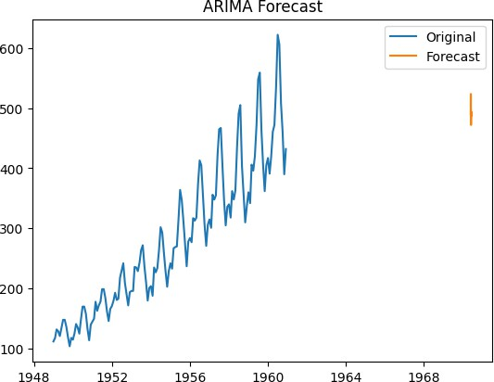
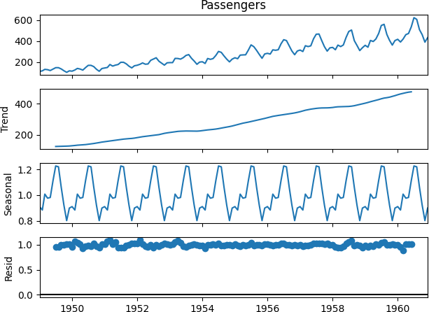
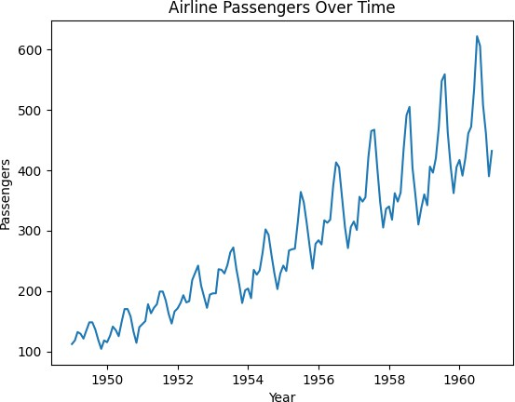

RESULT
Temporal mining techniques successfully revealed time-based patterns in the dataset. Rolling averages smoothed noise for clearer trend visibility. Seasonal decomposition separated the series into trend, seasonality, and residual components, enabling actionable insights about temporal behavior.

